|  |
| --- |
| **How to use SonarQube plugin in eclipse** |
| Author: Parag Phadtare |
| Date: 17/ 10 / 2016 |



Step 1:- Install SonarQube Plugin (<http://downloads.sonarsource.com/eclipse/eclipse/>) in your eclipse.

Step 2:- Create a sample project or import the one if you already have it in your eclipse.

Step 3:- Make sure you have SonarQube server installed on your computer. (Note: - This is required for local only. On client machine you may not need it. You can simply use the SonarQube server URL)

Start the SonarQube server.

Open SonarQube server console and login using admin/admin (unless you changed it)

Go To settings -> Provisioning -> Create Project

While creating the project you will have to provide project key name and project name.

Note: - You have to use the same project key in eclipse while associating your project with SonarQube

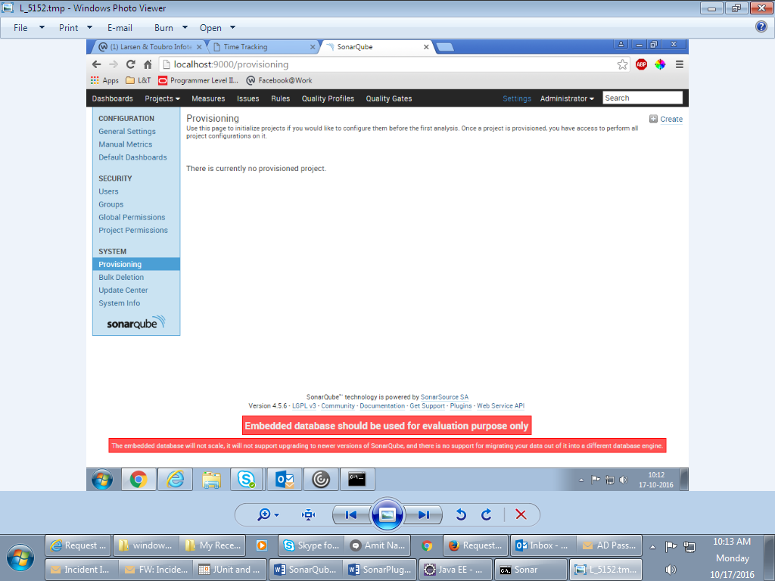

Enter key and project name

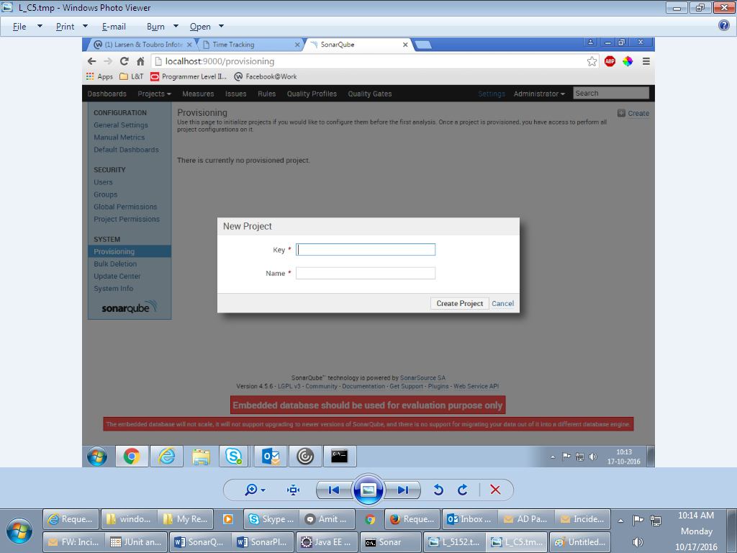

Enter the Key and Name and hit Create Project

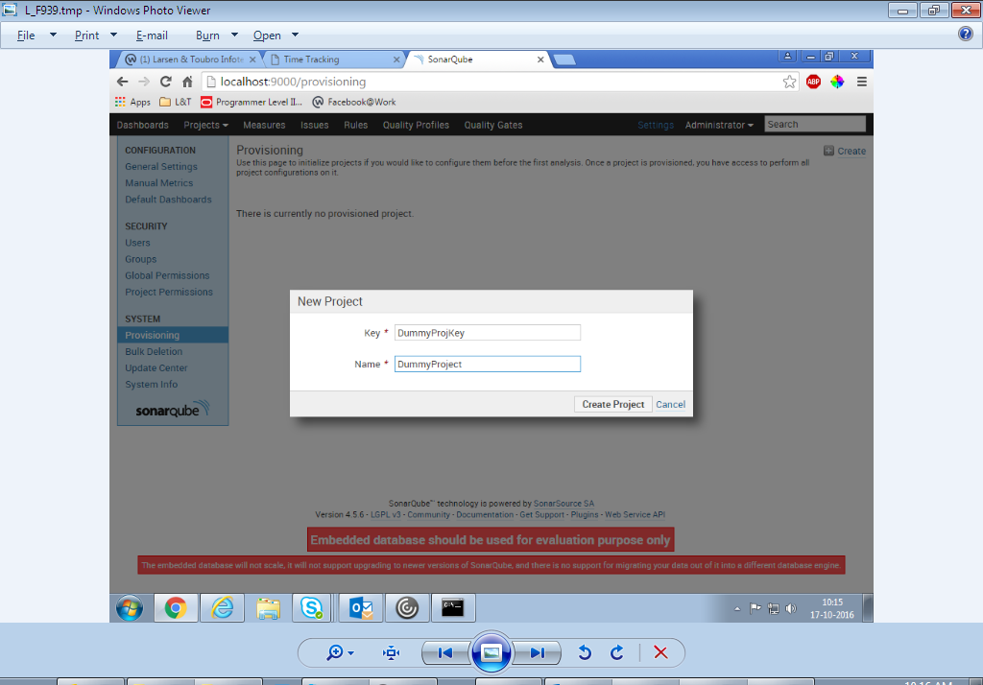

Step 4:- Go to Window -> Show View -> Other

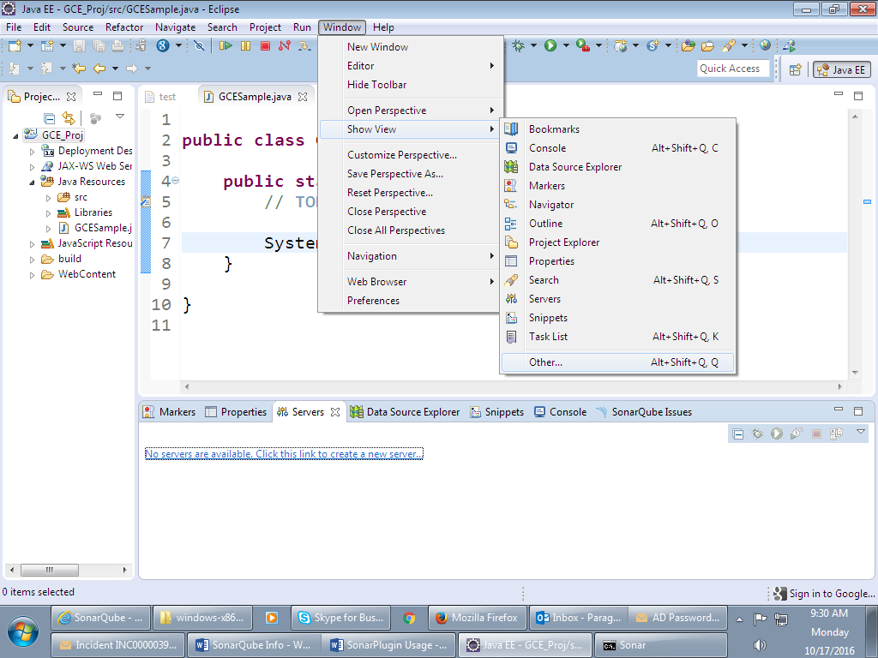

Open SonarQube Issues tab.

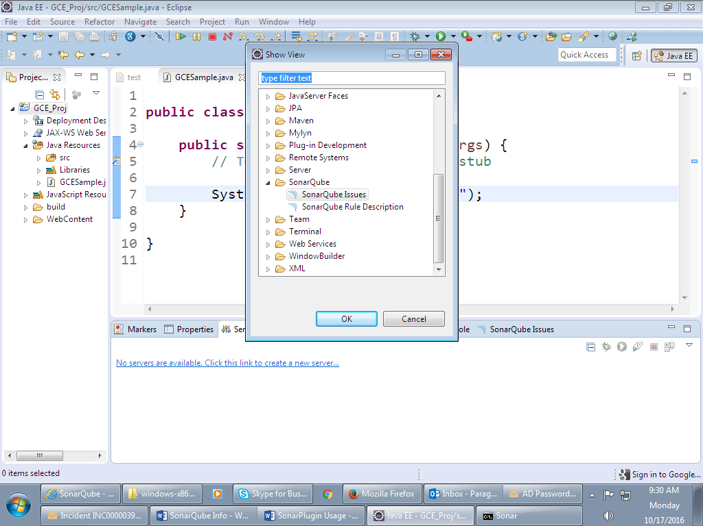

It shows the tab as following.

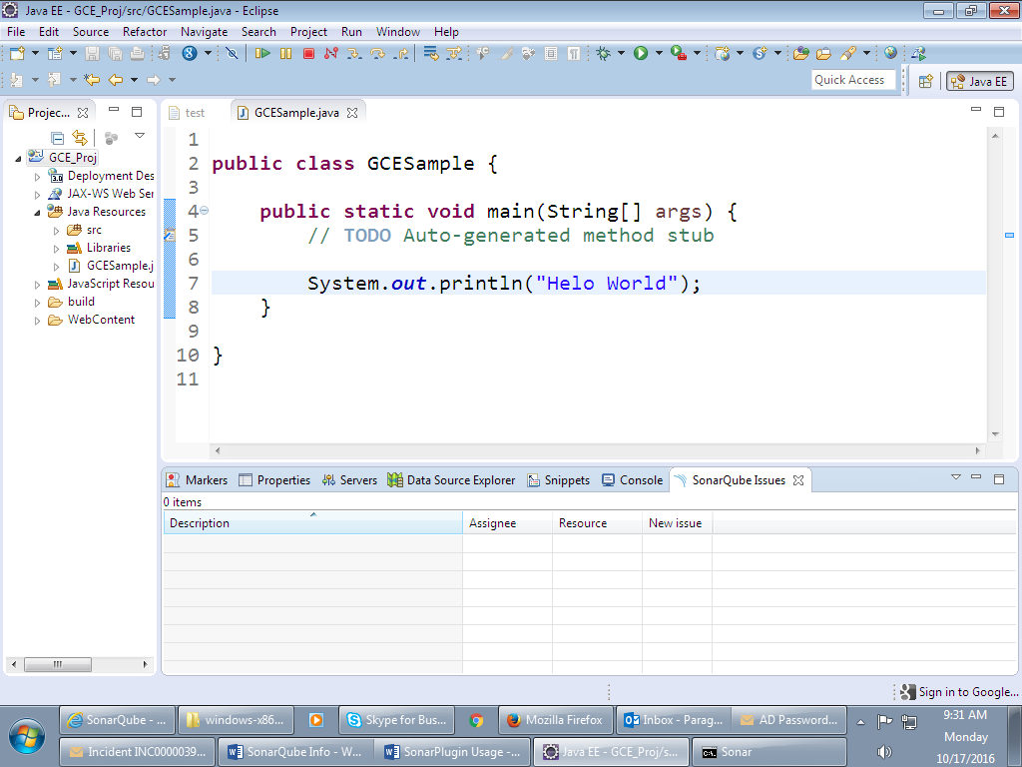

Step 5:- Go to Window -> Preferences

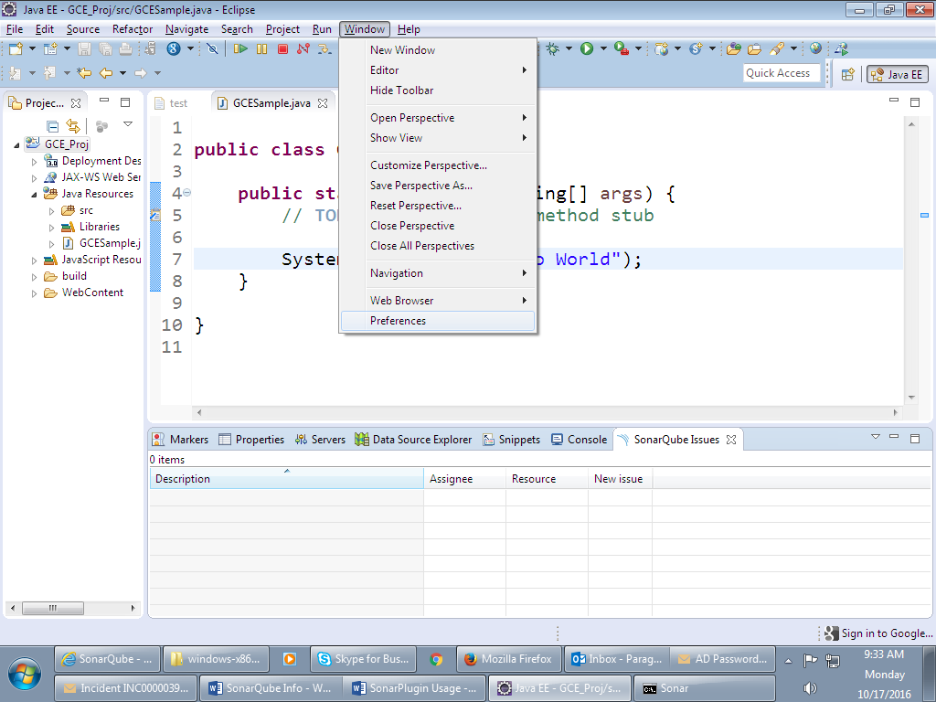

Locate SonarQube Servers as following.

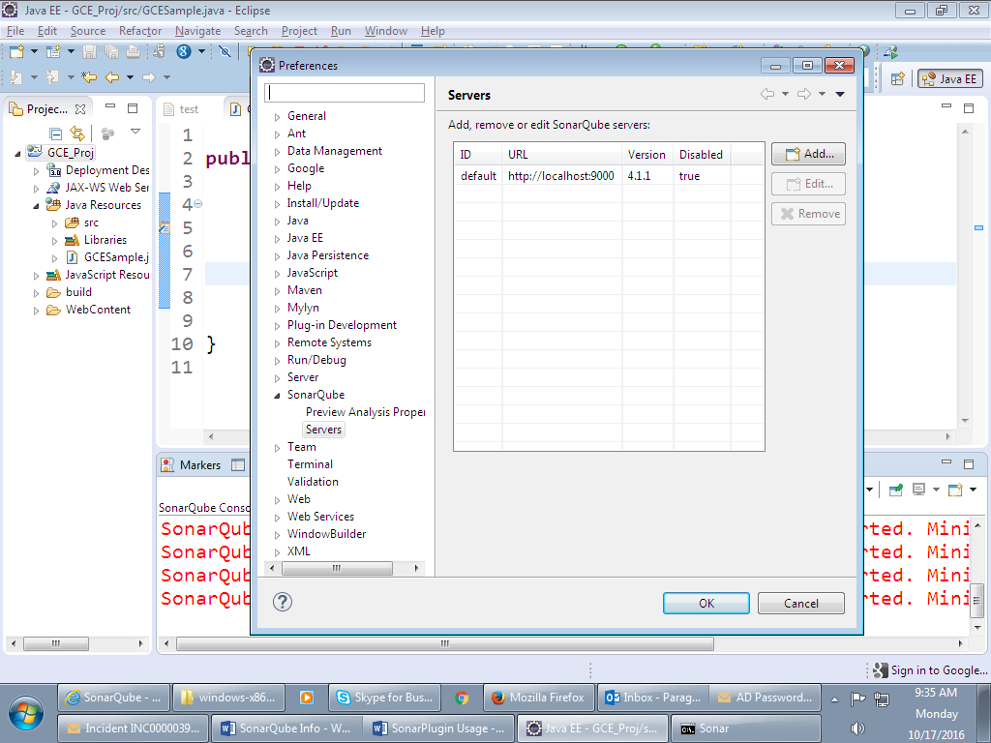

Select the server from the grid as following and click Edit.

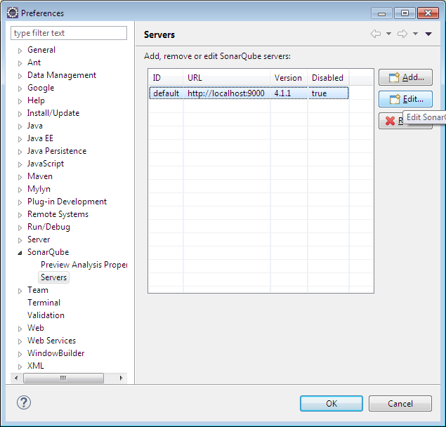

You will see following window. Click Test Connection to verify if connection done.

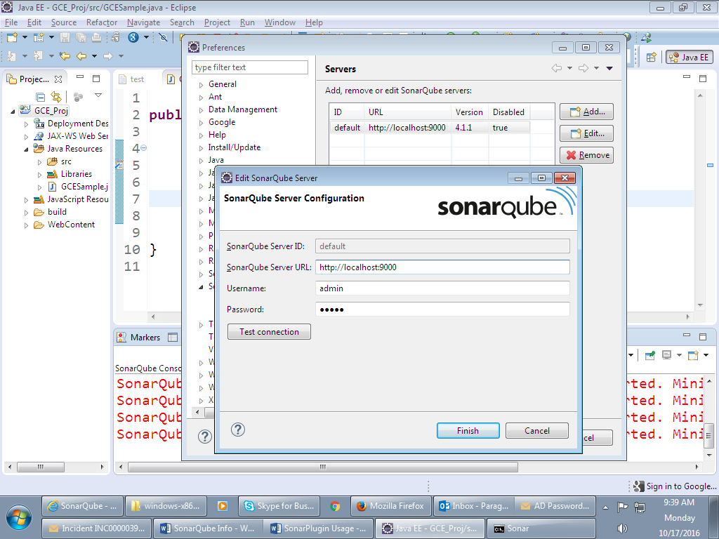

Successfully Connected message will appear.

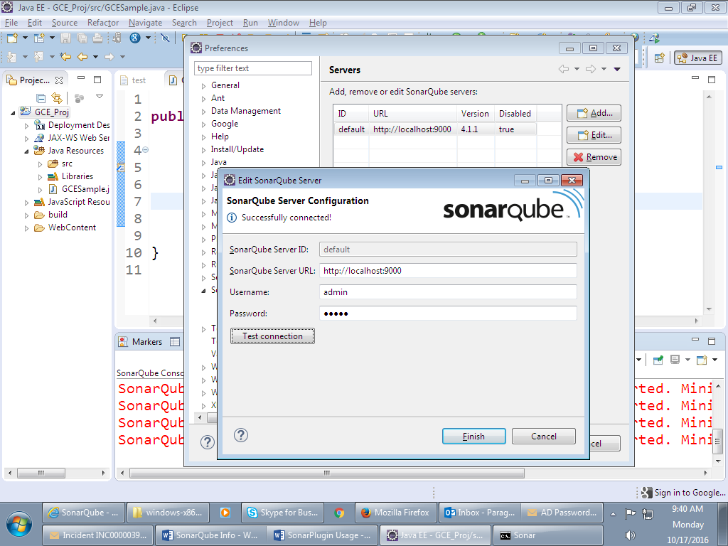

Right click on your project and locate Associate with SonarQube

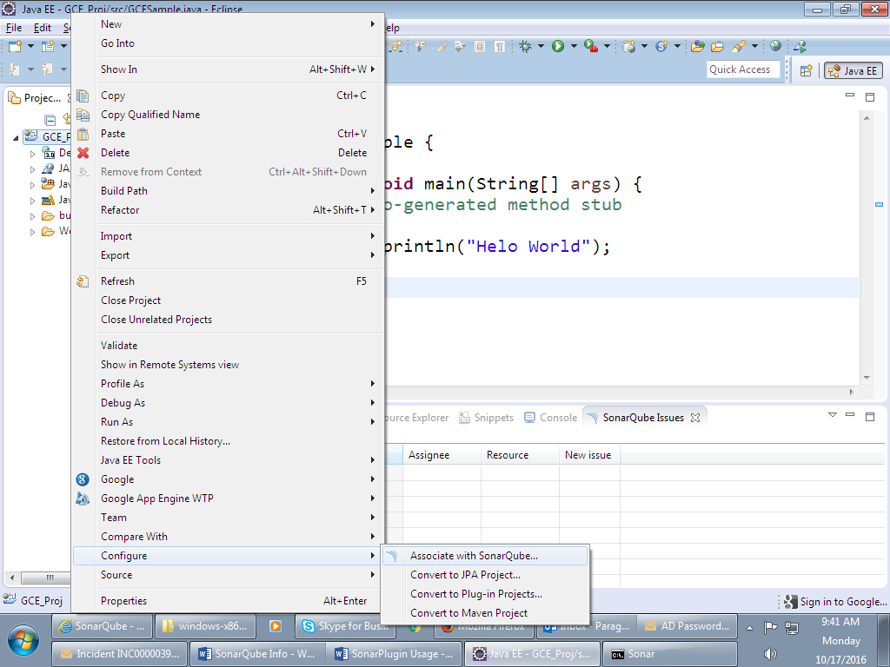

You will see following window.

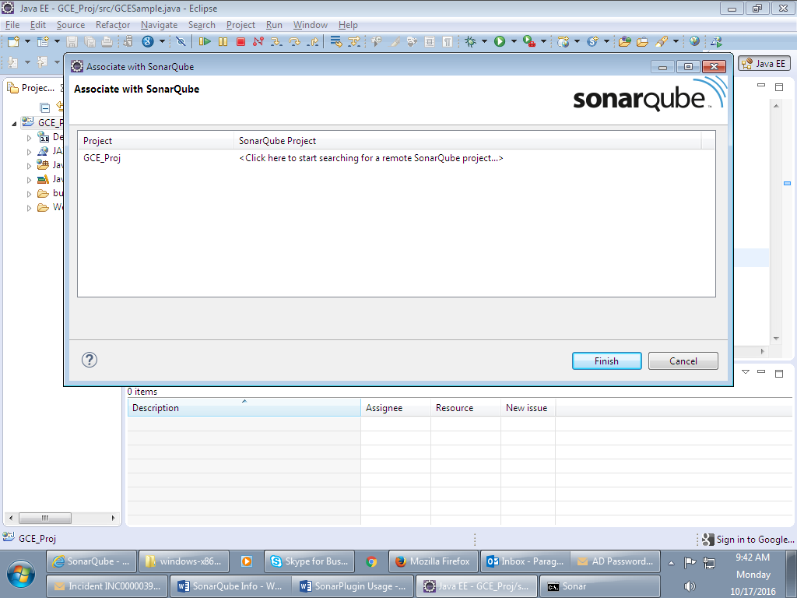

Search for the dummy project in the following window you had created on SonarQube in Step 3 and click Finish.

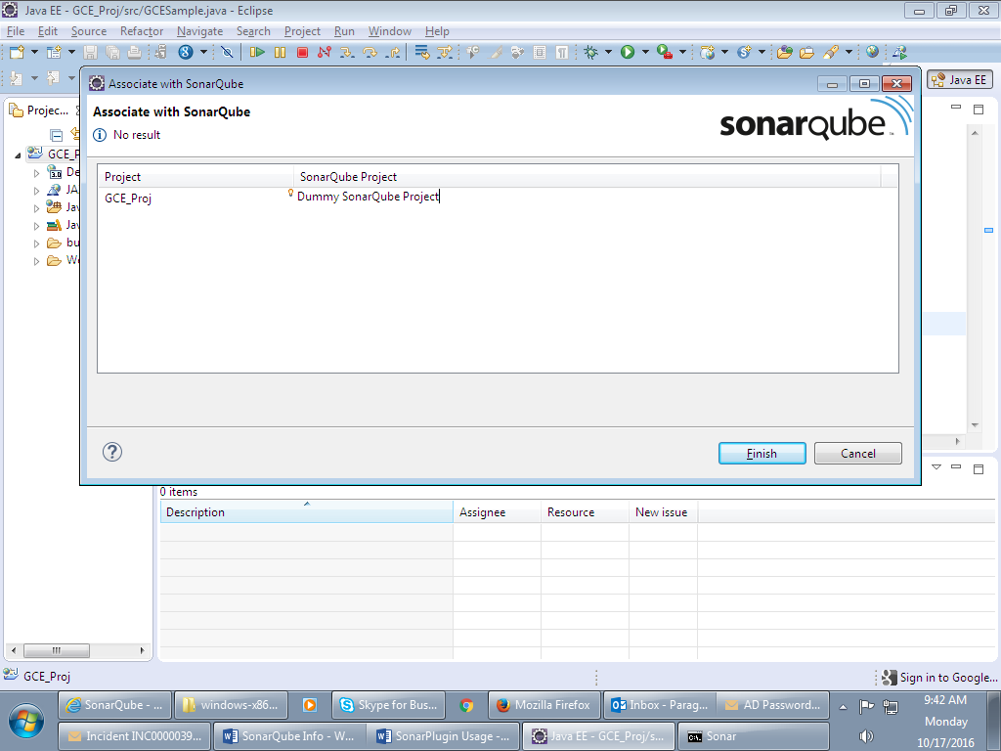

Right click on the project -> Configure -> Analyze

It should show you the SonarQube issues in the SonarQube issues tab.

When you fix a particular issue, you can right click on the project and analyze again to see if your issue got fixed or not.

# Exclusion of folders in Sonar Analysis through Eclipse Plugin

1. Exclusion is totally based on regular expression through Eclipse settings.

Following screenshot depicts the way to add your exclusion patterns.

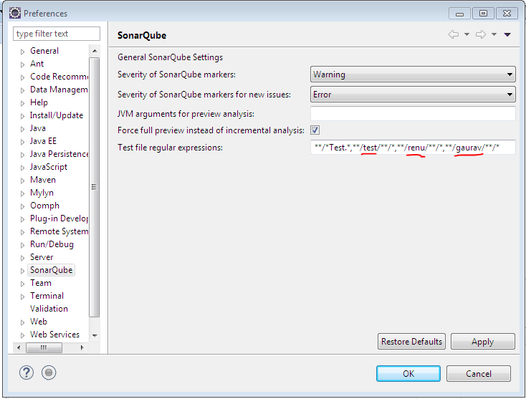

1. Project Structure before Analysis

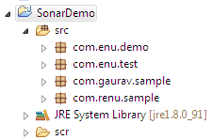

1. Once you associate the project with Sonar. Please follow the steps mentioned above in the document.

And keep the exclusions as mentioned in above screenshot.

1. Project Status after the Analysis

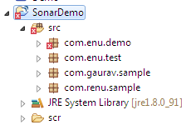

Please mark in the step 1 we have excluded everything except com.enu.demo, so are the results.

# Notes & Instructions

Fonts, Bullet style, Color palette, Pie charts, etc. to be in sync with that laid out in the ppt template.